**Practical No: 10** **Ninad Karlekar 22306A1012**

**Date: 20/04/2023**

**Aim: Working with Docker Volumes and Networks**

**Description:**

**Explain the concept of Docker Volumes and Networks**

**Code & Output:**

Perform Following Inside Play-With-Dokcer  
1) Pull nginx image into docker  
Command:  
docker pull nginx  
Output:

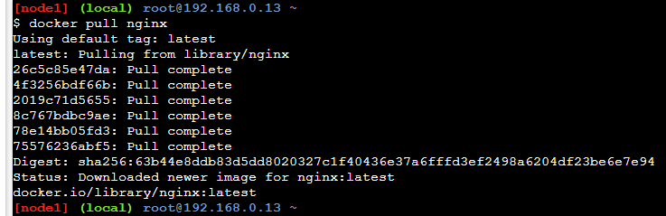

**2) Now run the pulled image in Conatiner named “webApp”**

**Command:**

**docker run -it --name=webApp -d -p 80:80 nginx**

**Output:**

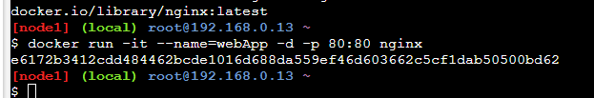

**3) Click on port 80 to check output (it shows welcome page)**

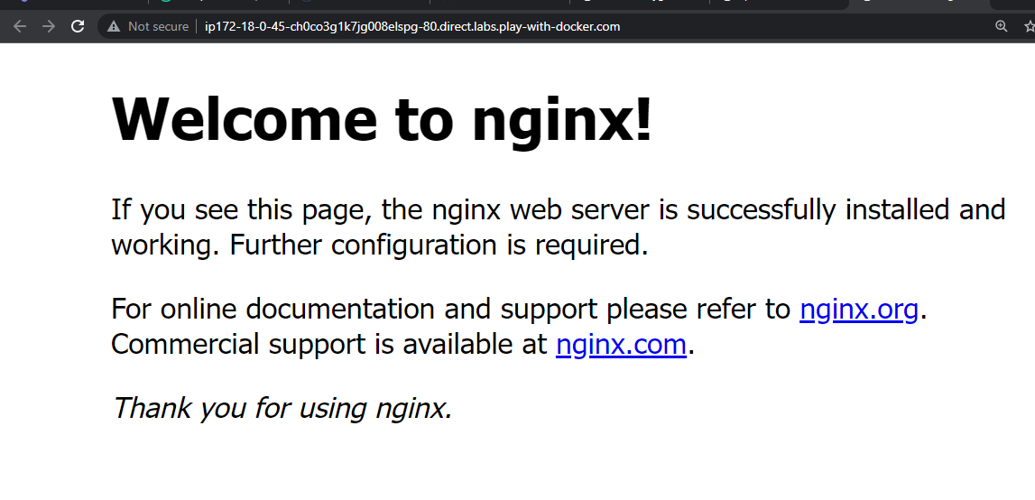

**4) We make changes into “index.html” file inside /usr/share/nginx/html folder**

**Commands:**

**docker exec -it webApp bash //this command to execute bash shell**

**cd /usr/share/nginx/html // to go inside html folder**

**echo "Hello NK" > index.html // to change content of index.html file**

**output:**

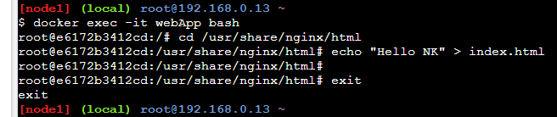

**5) Type exit to return to docker prompt and check process status using ps option**

**Commands:**

**Exit**

**Docker ps**

**Output:**



**6) Now refresh on port 80 output (you should get modified output)**

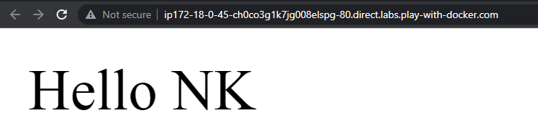

**7) Now stop running container named “webApp”.**

**Command:**

**docker stop webApp**

**output:**

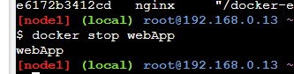

**8) Start nginx in new container named as “webApp1”.**

**Command:**

**docker run -it --name=webApp1 -d -p 80:80 nginx**

**output:**

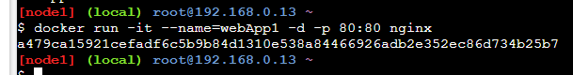

**9) Now Click on port 80 (you will see the welcome page again)**



**10) To solve this issue we create new volume.**

**Command:**

**docker volume create MyVolume**

**output:**

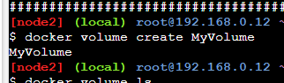

**11) Check volume is created**

**Command:**

**docker volume ls**

**output:**

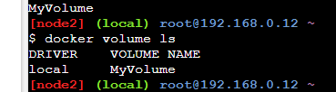

**12) Check details of volume**

**Command:**

**docker volume inspect MyVolume**

**output:**

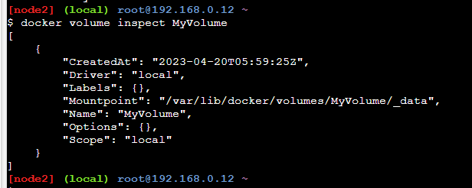

**13) Mount this volume to nginx new container named “webApp4”**

**Command:**

**docker run -d --name=webApp4 --mount source=MyVolume,destination=/usr/share/nginx/html -p 80:80**

**nginx**

**output:**

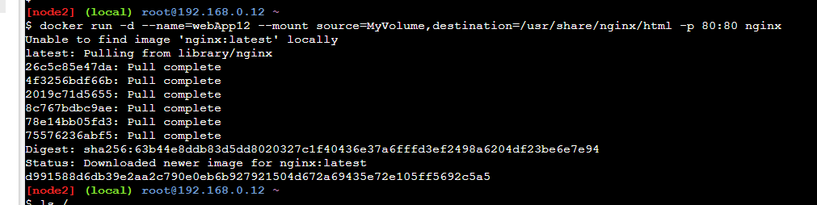

**14) Now keep on doing “ls” and “cd “ to go inside _data folder of our volume “MyVolume”**

**Commands:**

**ls /**

**cd /var/lib/docker**

**ls**

**output:**

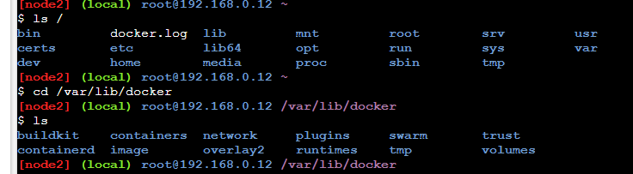

**Commands:**

**cd volumes**

**ls**

**cd MyVolume**

**ls**

**output:**

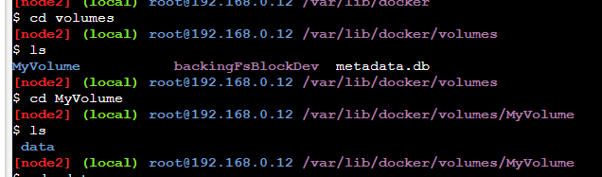

**Commands:**

**cd _data**

**ls**

**output:**

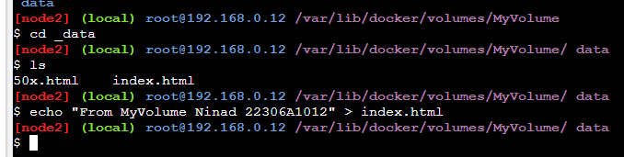

**15) Modify contents of index.html file with “from MyVolume hello KB”**

**Command:**

**echo “from MyVolume Ninad 22306A1012” > index.html**

**(note: don’t paste this type this)**

**Output:**



**16) Now refersh port 80 (to get modified output)**

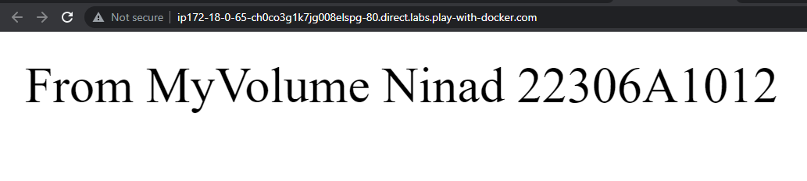

**17) Now stop this running container named “webApp4”**

**Command:**

**docker stop webApp4**

**output:**

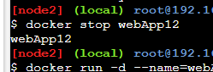

**18) Now run nginx in new container named “webApp6”**

**Command:**

**docker run -d --name=webApp6 --mount source=MyVolume,destination=/usr/share/nginx/html -p 80:80 ngin**

**output:**

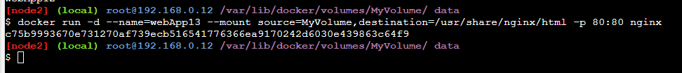

**19) Click on port 80 and refresh the page you should get edited file as output.**

**We can load the page again localhost:80 and still see the html file that we edited in the volume.**

**So, with the help of volumes, we can easily access the data even we stop the container and it’s very easy to access**

**data and import the data to anywhere.**

**Output:**

